Hi Mark! Here I’m sharing with you the layout that Oscar and I have made. It is meant to be for mobile and that’s how we would like it to look like when users visit the website from their phones. For what concerns the PC version, I trust your creativity and imagination in order to make a beautiful website based on our vision. Most importantly, this is meant to be a guide line. Not everything has to remain the same. So, here we go!

**LOGIN PAGE.**

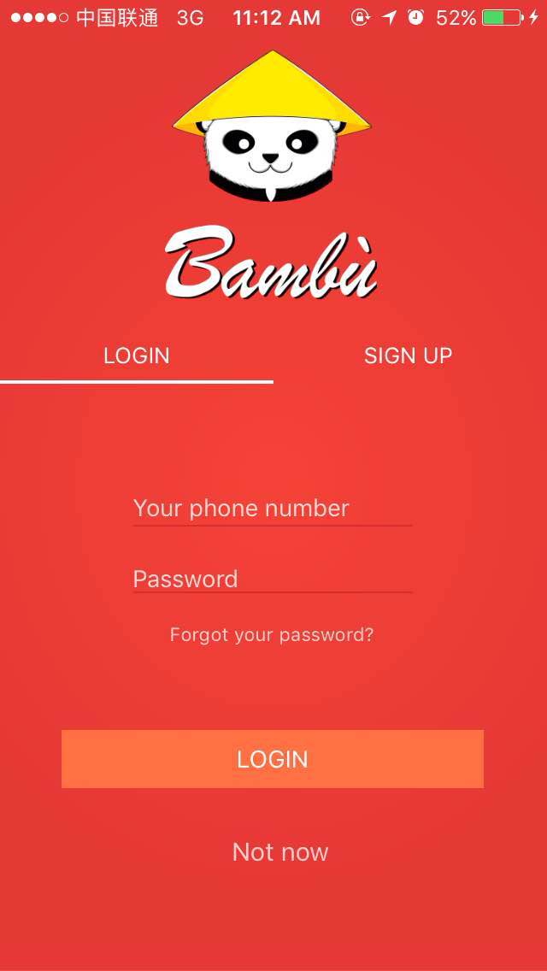

NOTES: This page should appear when a visitor click over the Login/Signup button. As you can see, it is not mandatory to sign up or login, by clicking “Not now” users will be redirected to the Home Page. However, we want to prevent users to contact sellers or post pictures unless they are registered.

**SIGN UP.**

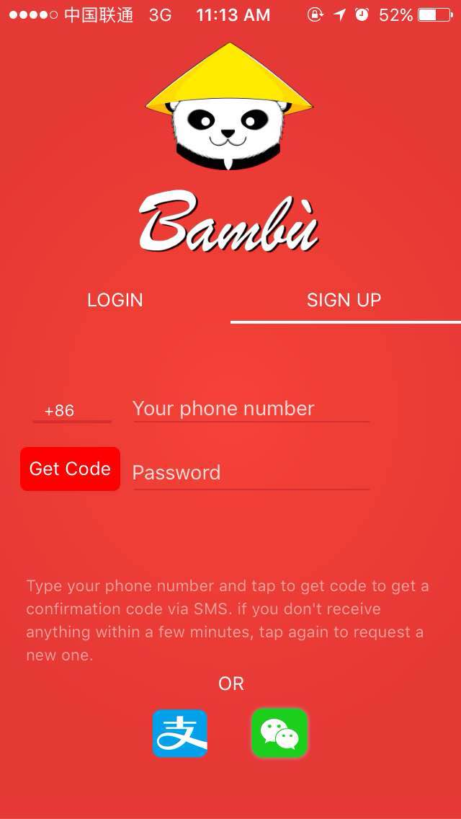

Notes: Here you can have an overview of what channels we want to provide our users with in order to sign up. Phone number, Wechat, and actually, instead of Alipay, we were considering adding Facebook. Many foreigners feel more accustomed with that other than Zhifubao.

**HOME PAGE.**

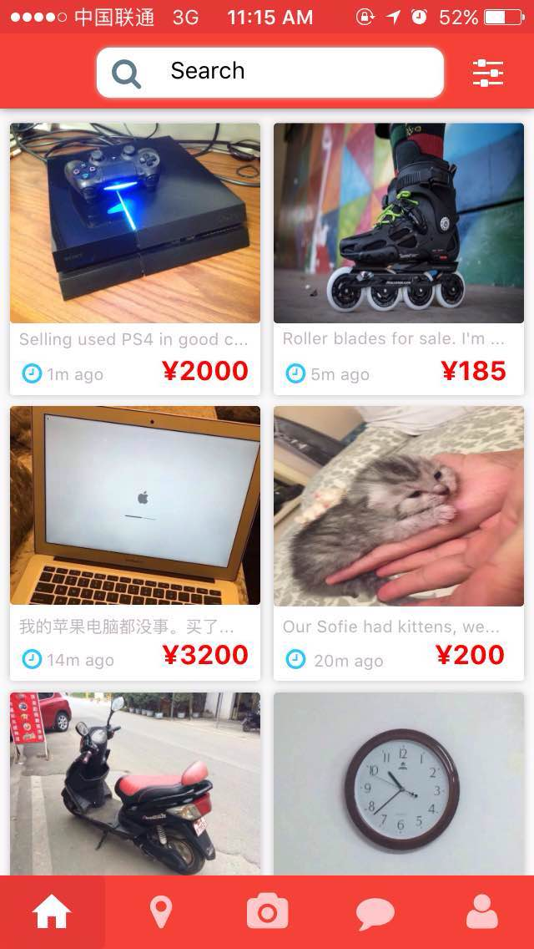

2.

1.

**COLOR PALETTE:**

1. # f44336

R: 244

G: 67

B: 54

1. # e53935

R: 229

G: 57

B: 53

2.

1.

This is the Home Page. Big pictures, essential information (i.e. Price, Time of post, Beginning of description). A long Search Bar on top with the advanced research option aside. For your reference, you can look up the website letgo.com They layout is quite similar.

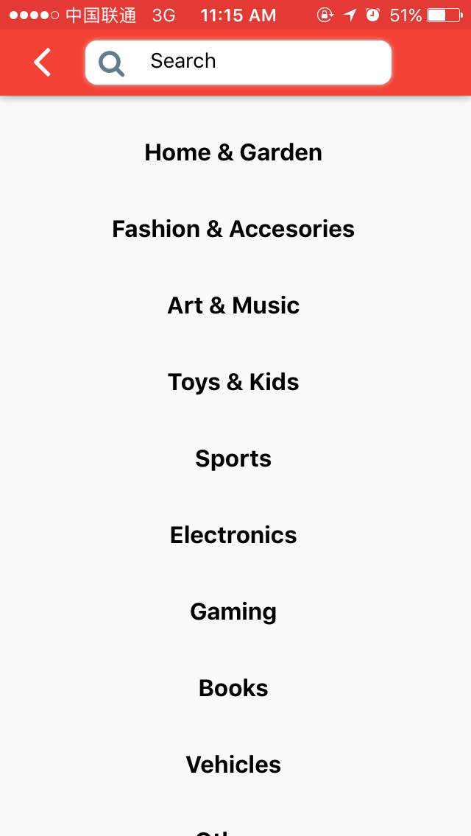**ADVANCED RESEARCH OPTION PAGE.**

Advanced is a big word…eheh. Let’s say Categories. If you want to add icons on the side of the words, feel free.

**NEARBY PAGE.**

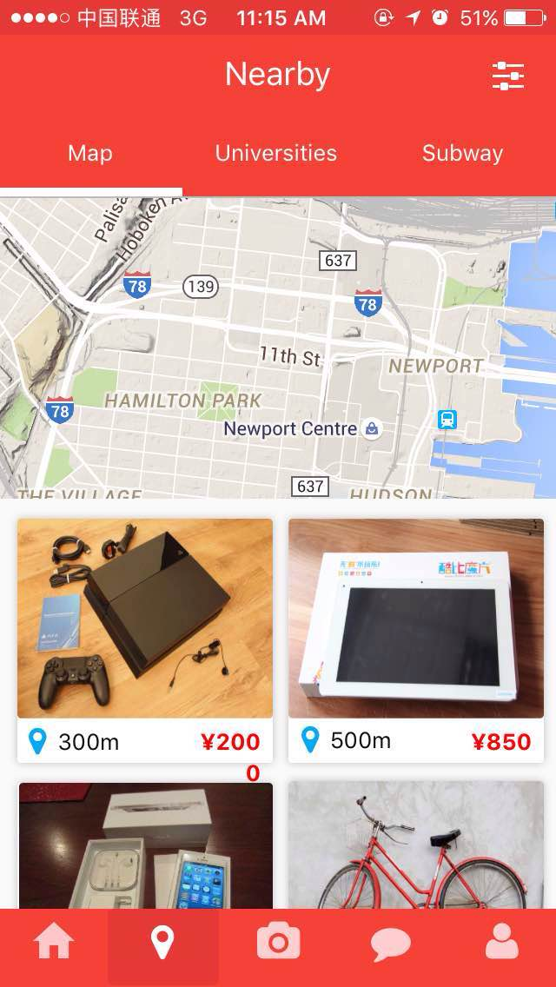

So, we are moving on through the bottom menu, aka “The Dock”. As you can see, the icon changes color according to the page we are on.

On this page, there are three different options for refined research: 1) By map – using gps localization it should show the sellers around your area 2) By Universities and 3) By Subway.

These last two options we can implement later in time. We can ask sellers to add additional information so that we can categorize their items in such manner.

Also, notice that on the Item squares now it is displayed the distance instead of the posting time as in the Home Page.

**FILTER POP-UP OPTION.**

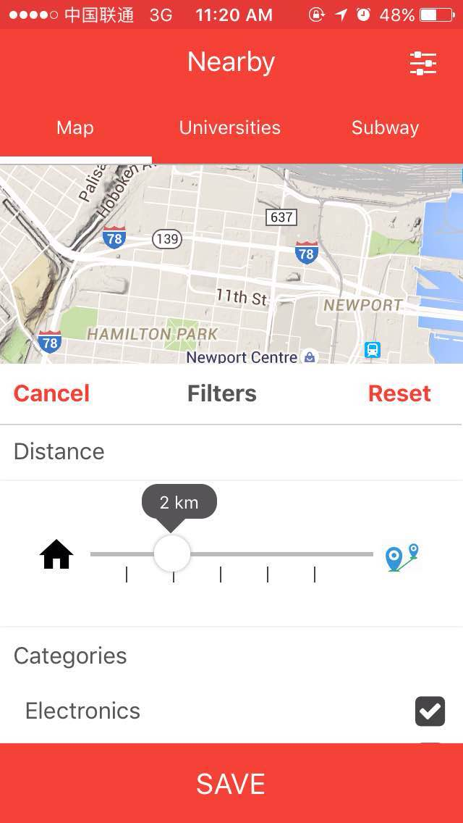

Notes: On the Nearby Page, up right, there is the filter for refined research. Here it is displayed how we were visualizing it.

**ITEM DESCRIPTION PAGE.**

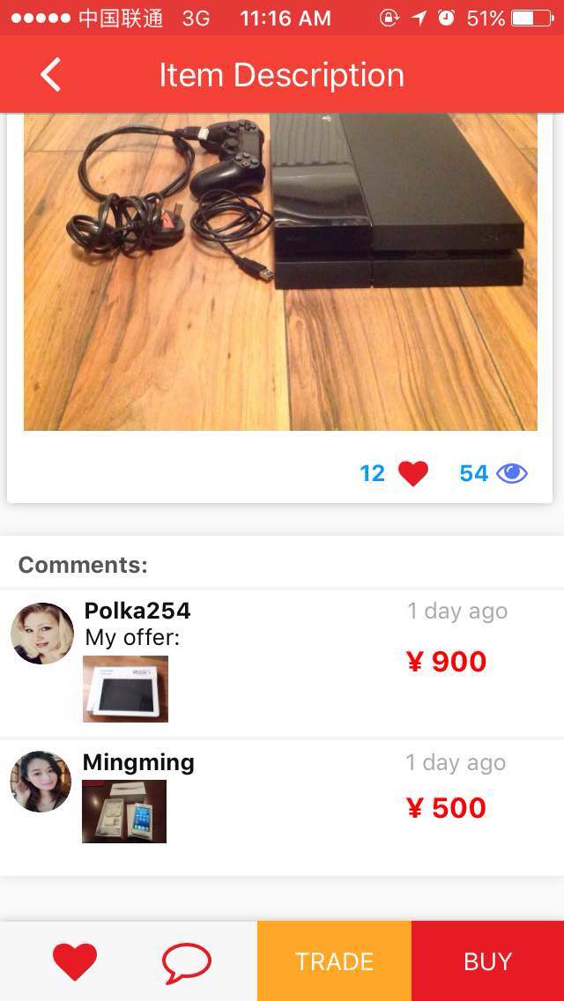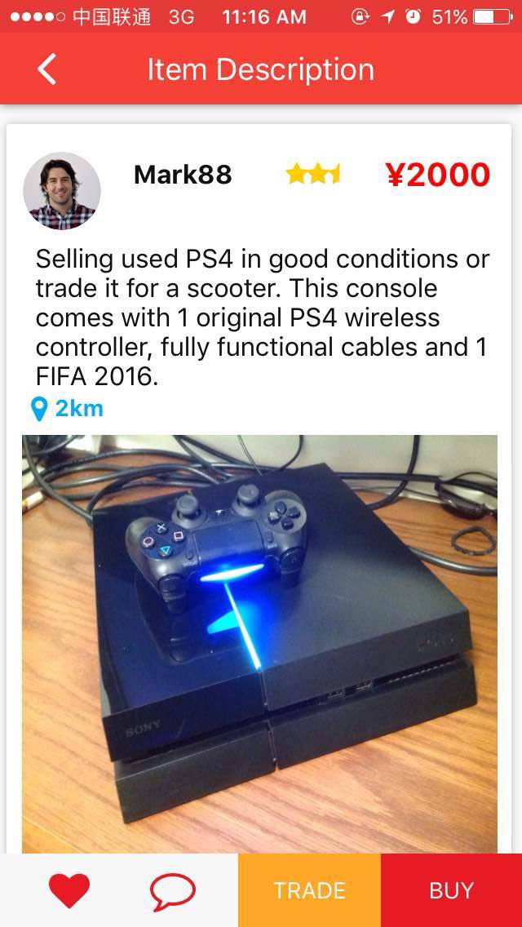

A

This is the format of the page that will appear when a user click on an item box. There is the seller picture, name a ratio (5 stars as the highest – we can discuss the details of this function later on). When a picture is clicked, I was thinking of a gallery view, so that the user can comfortably browse through and make up his/her mind. At the bottom of the picture box (A) are shown the likes and how many times this item was viewed.

Comments Area: As you see, there are the comments that people have made regarding the object. Now, I was thinking of changing that. We could put a text box with written “leave a comment” with all the previous comments and then another section where we place the offers (which will be issued through the Trade button – shown below) [Red Circle].

The Buy button can be removed for now, in the moment of which we don’t support online payment method yet.

**TRADE PAGE.**

By clicking this button, the following page should appear:

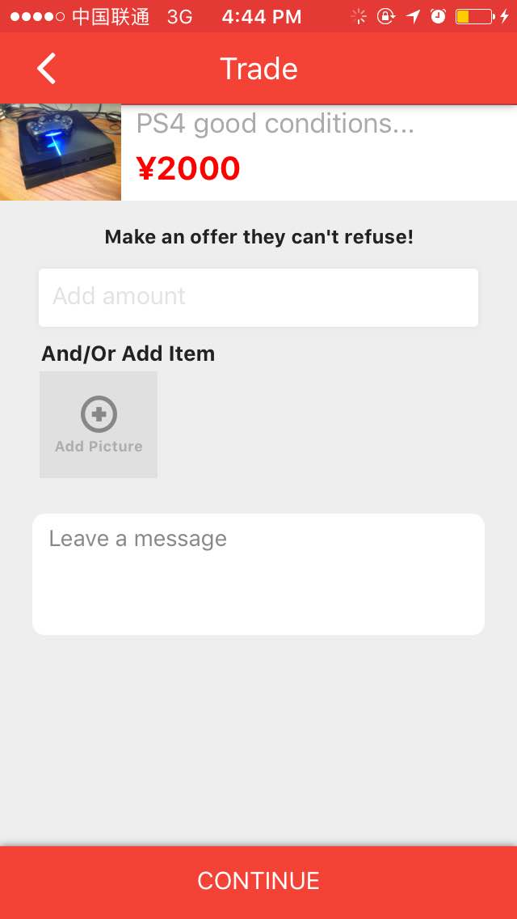

We thought of this function as a public one, so that other users will be able to see pre-existing offers and regulate themselves accordingly.

Afterward, it will be up to the seller to contact the person with the offer he/she likes the most and arrange the trade.

In this section, it is possible to offer either money, an item, or both.

Again, do feel free to organize things according to your own liking. This is all a rough guide line on what kind of functions and pages we are thinking to display.

Everything can change, nothing is still and immobile.

**CHAT PAGE LINK.**

By clicking this button, the following page should appear:

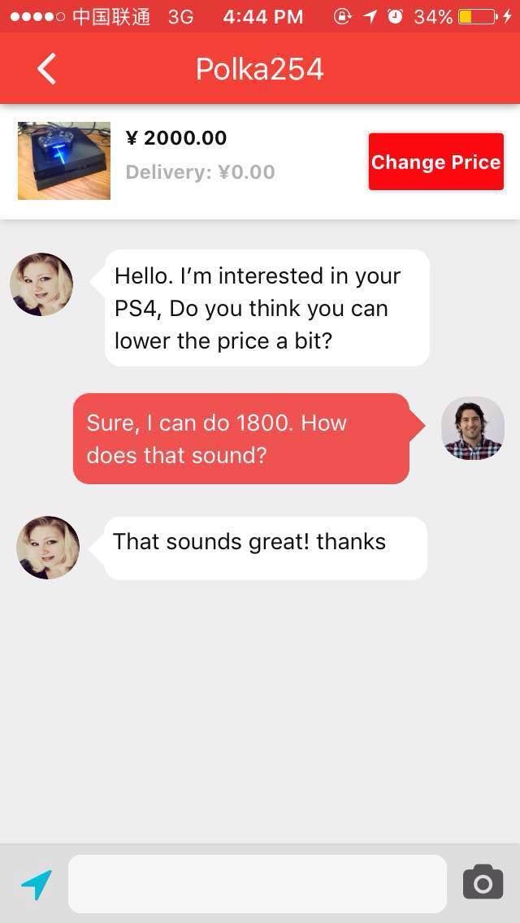

This is the normal chat page. Once an interested user has made up his/her mind, they will contact the seller in private chat and discuss about the item.

The page you are seeing is on the seller point of view. Here they will have the chance to talk about the item in question, bargain, and eventually exchange contacts.

We were wondering whether there is the possibility to apply a translation software here, similar to wechat, you know? For which it just needs a right click (or an option somewhere on the page) and they can better understand each other.

The camera option has the function of allowing the posting of a picture related to the discussion. Let’s say I’m offering you my scooter for the ps4 and you want more pics of it. I simply click there and it allows me to post them in the chat directly.

Notes: It is likely that most of the conversation will take place on wechat; however, I believe it is important to set up a comfortable environment on the website so as to retain as many users as possible for the longest course of time. Which is quite the point of all this ☺

Oh also, the location icon is for sharing the location, duh .. very similar to wechat.

**POST PAGE.**

By clicking this button, the following page should appear:

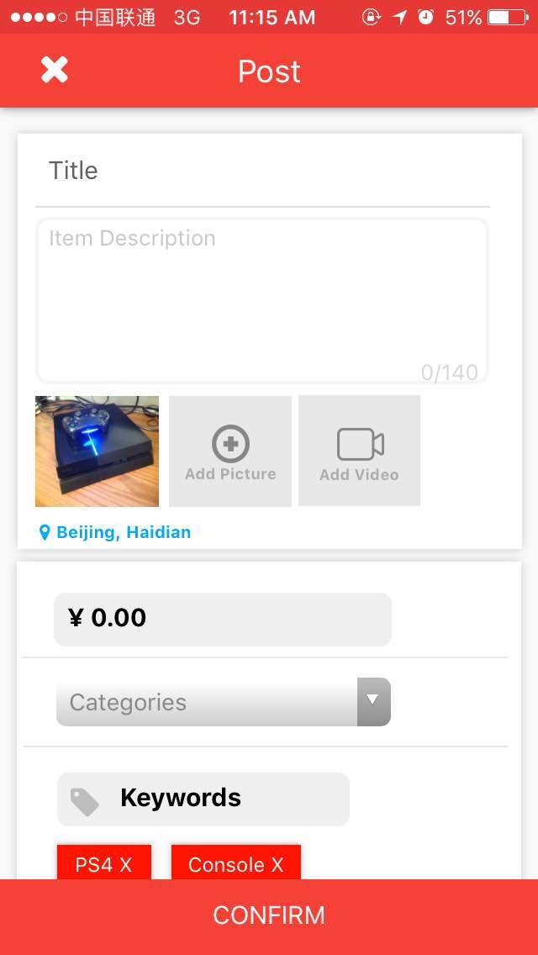

Very simple 5 steps posting process.

1. Set a Title for the Item
2. Short description, let’s say 140 characters 左右
3. Add at least one picture of the item or a Video.
4. Set a price

4.1) Categories and keywords are technically optional. But it will help other users to find the item more easily.

1. Confirm and Post.

**CHAT PAGE.**

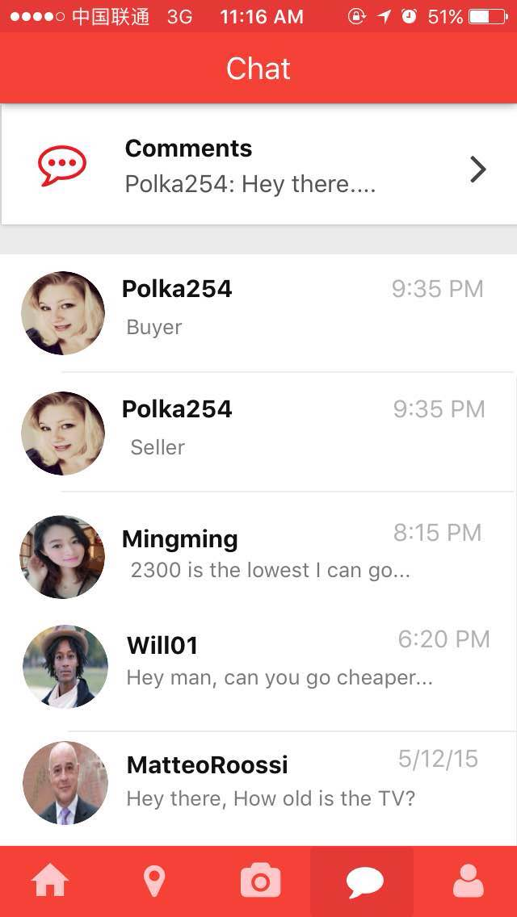

Moving on, Chat page. Here we’ll have represented the chat logs of one user.

Including the option to see all the comments made on the posts.

For a clearer notification process, I was thinking of placing a Notification Icon in the Home page so that users will be quickly notified when someone contacted them or made a comment.

For this part, you can take inspiration from Facebook or LinkedIn.

**PROFILE PAGE.**

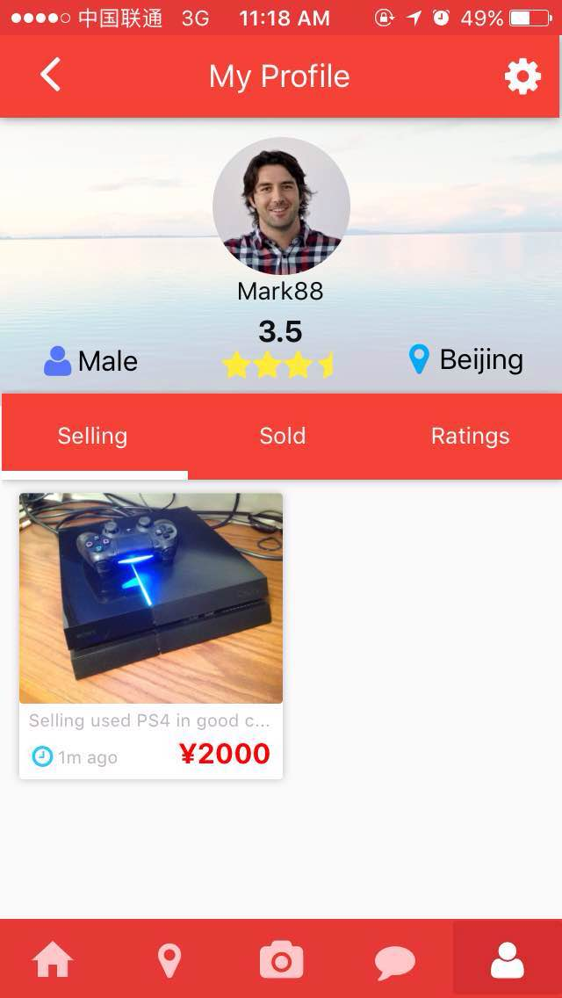

Profile page. Very simple, clean and basic.

We can display the items being sold, the sold ones and the ratings (or comments made on the seller)

For the background picture, I was thinking of either letting the user put his own, or choose among a selection of ours; and in order to change both profile picture and background picture, just need to hover the pointer over either one of those and select “change picture”. Same as Facebook.

The background picture has a mildly grey layer that allows the black of the user name to be enhanced and seen.

**PROFILE PAGE – SETTINGS & RATINGS.**

****By clicking this buttons, the following pages should appear:



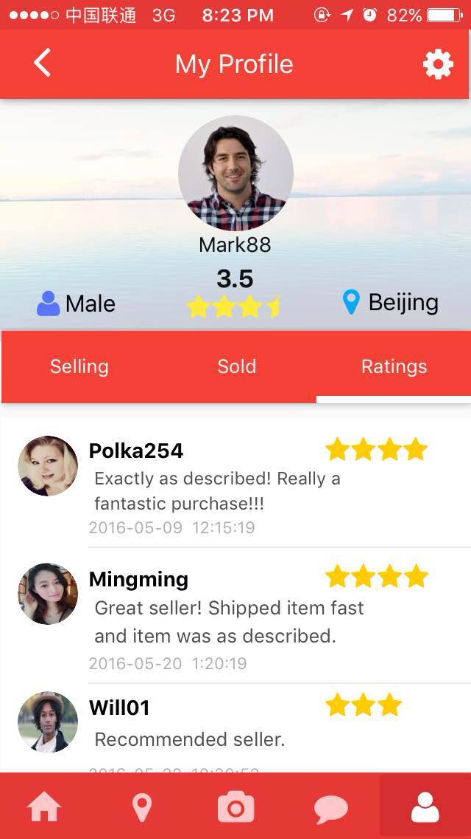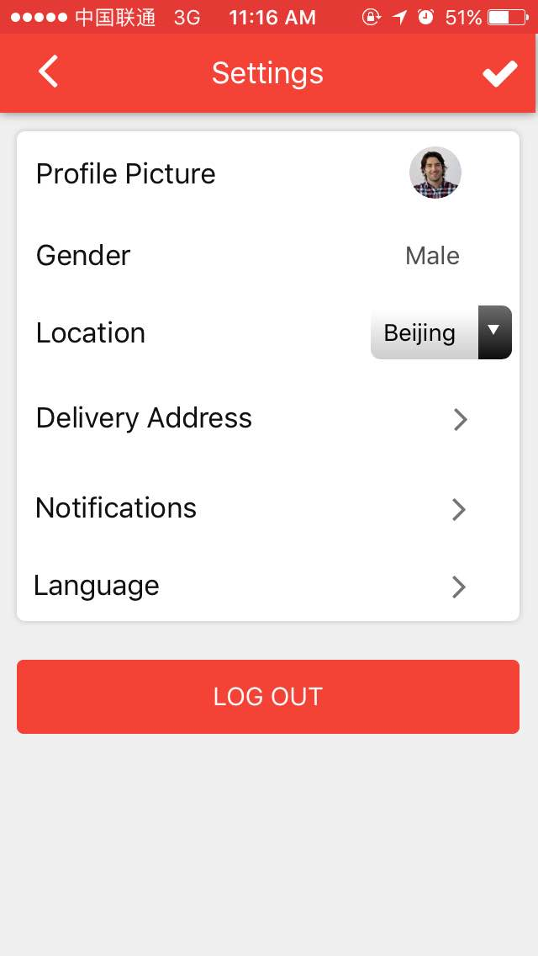

Here we can put the most basic settings. Delivery address won’t be needed and also I was thinking that for the PC version to have the language setting in the top right of the Home Page. If you can think of some other things to place among the settings, feel free.

Alright then, this is it. Again, this is just meant to be a guide line with the pages that we would like to see up on the website. It would be great if it can be displayed this way when users are going to the website from their mobile phones. If you have any question, I’m always on my phone so you can simply text me or give me a call at +86 130 1104 1422

For the development of such a thing, I’m willing to offer to You and your selected backend friend 800RMB each. Deadline should be by the end of December 2016. Let me know what you think !